43.1: a) 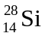has 14 protons and 14 neutrons.
b) 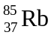has 37 protons and 48 neutrons.
c) 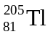has 81 protons and 124 neutrons.

